**Winter tour: Ski Base Karakol**

Country: **Kyrgyzstan**

Period: **December-March**

**Days: 7 / Nights: 6**

Organizing any complexity of tours to Issyk-Kul, Son-Kul, around Kyrgyzstan and Central Asia. We guarantee you high quality of service and individual approach!

Enjoy the beauty of Kyrgyz nature and our celestial mountains at the most famous ski base in Kyrgyzstan. The base is situated on 2300 meters above sea level and is located not far from the largest alpine lake - Issyk-Kul.  
You will have a beautiful panoramic view of Issyk-Kul lake from the highest point (3040 m)  
There are four chairlifts and different ski runs for professionals and beginners.  
The ski season starts in November and lasts up until April. All this time you should not worry about the snow - it covers the ground with a dense 1.5 - 2.5 m.

#### [Day 1: Arrival to Bishkek Airport](https://concept.kg/en/tours/inbounds/43/#program_collapse_204)

Arrival to Bishkek Airport, meet with your local guide and transfer to city.  
Sightseeing tour of Bishkek city main highlights.  
Overnight at hotel (check-in after 14:00).

#### [Day 2: Bishkek – Chon-Kemin](https://concept.kg/en/tours/inbounds/43/#program_collapse_205)

After breakfast depart to Chon-Kemin Valley. En-route visit Burana Historical Complex consisting of a minaret, open air museum of Balbals (stone figures) and a small nearby archeological museum.  
Arrival to Kalmak-Ashuu village and accommodation at guest house.  
Lunch and dinner at guest house  
Evening free time for leisure, time for exploring the countryside.

#### [Day 3: Chon-Kemin - Karakol](https://concept.kg/en/tours/inbounds/43/#program_collapse_206)

After breakfast depart to Karakol.  
Visit open air Petroglyphs Museum (stone inscriptions) and Rukh-Ordo Cultural Complex in Cholpon-Ata.  
Arrival to Karakol, accommodation at guest house.  
If time permits sightseeing tour of Karakol town.  
Dinner at a local restaurant.

#### [Karakol: Karakol](https://concept.kg/en/tours/inbounds/43/#program_collapse_207)

After breakfast transfer to Karakol ski-base (7km) and full-day skiing.  
In the evening arrival back to guest house and overnight.

#### [Day 5: Karakol](https://concept.kg/en/tours/inbounds/43/#program_collapse_208)

After breakfast transfer to Karakol ski-base and full-day skiing.  
In the evening arrival back to guest house and overnight.

#### [Day 6: Karakol - Bishkek](https://concept.kg/en/tours/inbounds/43/#program_collapse_209)

After breakfast drive to Bishkek through south shore of the Issyk-Kul Lake. On the way visit Jeti-Oyz Gorge.   
Arrival to Bishkek, accommodation at hotel.  
Dinner at a local restaurant.

#### [Day 7: Departure from Bishkek](https://concept.kg/en/tours/inbounds/43/#program_collapse_210)

Transfer to the Airport for the departure flight.

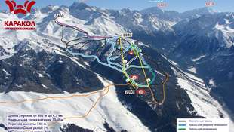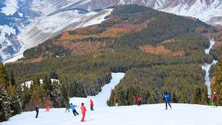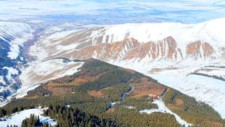

| **GROUP SIZE** | **PRICE IN USD/PER PERSON** |
| --- | --- |
| 5 | 946 USD |
| 10 | 805 USD |
| 15 | 708 USD |
| Supplementary for single accommodation | 264 USD |

| **PRICE INCLUDES** |  |
| --- | --- |
| Twin based accommodation | Bishkek - 3* hotel (2 o/n)  Chon-Kemin - guesthouse (1 o/n)  Karakol - guesthouse (3 o/n) |
| Transport | Sedan for 2 pax Minibus for up to 16 pax |
| Guide services (Eng/Russ) | Included |
| Entrance fees | Mentioned in the program |
| Meals | Mentioned in the program |

| **PRICE EXCLUDES** |
| --- |
| Personal expenses |
| Insurance |
| Cable car passes at ski base |
| Equipment for skiing, snowboarding, etc. |

**Contact information:**

[www.travelscruiser.com](http://www.travelscruiser.com)

Phone (24/7): +996 …………., +996 ……….

E-mail: [info@travelscruiser.com](mailto:info@travelscruiser.com)